1. The table below shows the Truth table of Half Subtractor, write SOP expression for difference and borrow and design the circuit using Logsim.

|  |  |  |  |
| --- | --- | --- | --- |
| **A** | **B** | **Difference** | **Borrow** |
| **0** | **0** | **0** | **0** |
| **0** | **1** | **1** | **1** |
| **1** | **0** | **1** | **0** |
| **1** | **1** | **0** | **0** |

**Answer:**

SOP Expression of Difference is A’B+AB’ and

SOP Expression of Borrow is A’B.

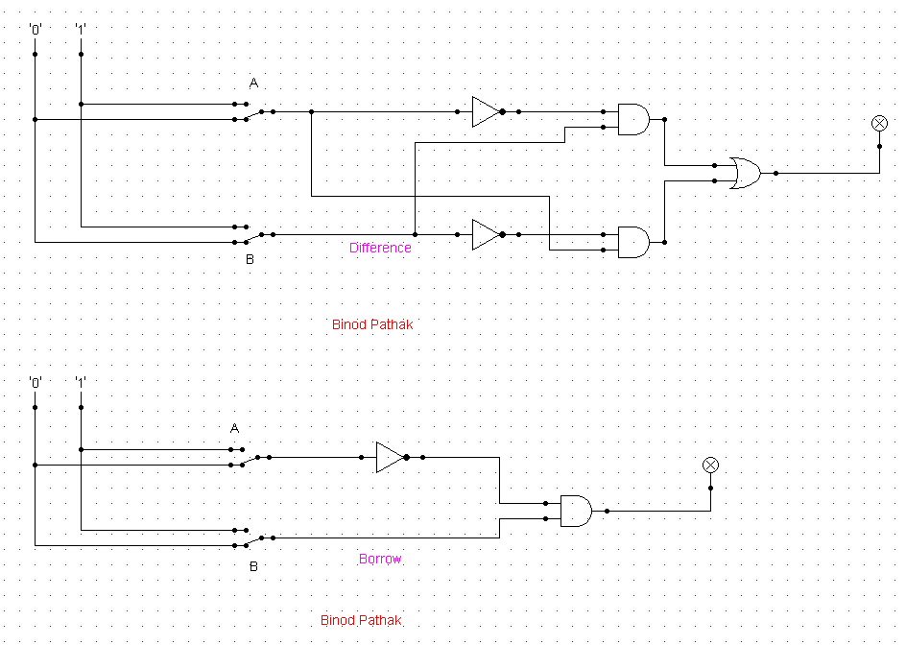

1. Design 2:4 decoder using logsim and Construct Truth table.

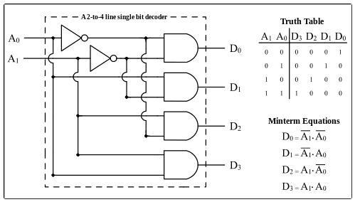

**Answer:**

|  |  |  |  |  |  |
| --- | --- | --- | --- | --- | --- |
| **A1** | **A0** | **D3** | **D2** | **D1** | **D0** |
| **0** | **0** | **0** | **0** | **0** | **1** |
| **0** | **1** | **0** | **0** | **1** | **0** |
| **1** | **0** | **0** | **1** | **0** | **0** |
| **1** | **1** | **1** | **0** | **0** | **0** |

SOP Expression:

D0=A1’.A0’

D1=A1’.A0

D2=A1.A0’

D3=A1.A2

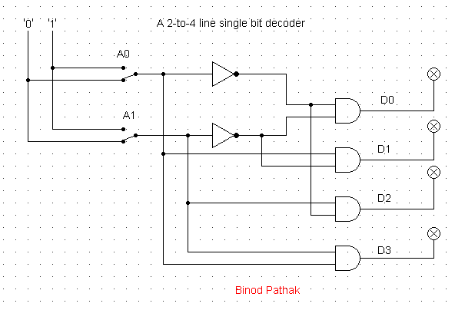

1. Draw the following simple ALU circuit using Logsim and describe the outputs when instructions are 1 and 0.

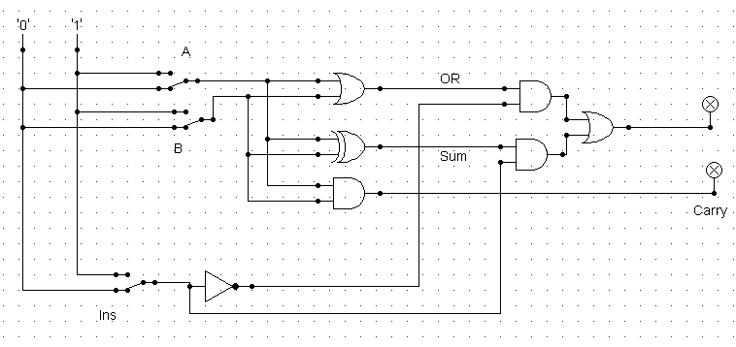

**Answer:**

|  |  |  |
| --- | --- | --- |
| **Inputs** | **Sum** | **Carry** |
| 0, 0, 1 | 0 | 0 |
| 0, 1, 1 | 1 | 0 |
| 1, 0, 1 | 1 | 0 |
| 0, 0, 0 | 0 | 0 |
| 0, 1, 0 | 1 | 0 |
| 1, 0, 0 | 1 | 0 |
| 1, 1, 0 | 1 | 1 |
| 1, 1, 1 | 0 | 1 |

1. Write short notes on the following topic:
2. ALU

**Answer:** A digital circuit that can do both arithmetic and logic operations is known as an arithmetic logic unit (ALU). It stands for the core component of a computer's central processor unit (CPU). ALUs in modern CPUs are quite strong and smart. Today's CPUs also have a control unit in addition to ALUs (CU).

One or more ALUs load data from input registers to carry out most of the CPU's operations. A register is a tiny storage space that is a component of a CPU. The ALU receives instructions from the control unit on what operation to do on the data, and it then saves the outcome in an output register. The data is transferred between these registers, the ALU, and memory via the control unit.

Binary numbers, or 0 and 1, are used to store and modify any kind of data in computers. Since a switch has just two possible states—open or closed, transistor switches are used to alter binary numbers. An open transistor, through which no current flows, is equivalent to 0 and a closed transistor with a current flowing through it indicates 1. Multiple transistors can be connected to perform operations. It is possible to utilize one transistor to control another, effectively turning the transistor switch on or off based on the status of the second transistor. Because the setup can be used to start or stop a current, which is known as a gate. Basic arithmetic and logical operations are carried out using an ALU. Addition, subtraction, multiplication, and division are a few examples of arithmetic operations. Comparisons of values using the NOT, AND, and OR operators are examples of logic operations.

1. Decoder

**Answer:** Decoders are the combinational circuits that convert binary data into 2N output lines. N input lines are used to transmit the binary data. The binary data's 2N-bit coding is defined by the output lines. Simply put, the Decoder executes the Encoder's process in reverse. For simplicity, just one input line is active at once. The binary data is equivalent to the 2N-bit output code produced.

2-to-4-line decoder: There are three inputs (A0, A1, and E) and four outputs (Y0, Y1, Y2, and Y3) in the 2-to-4-line decoder. When the enable 'E' is set to 1, one of these four outputs will be 1 for each combination of inputs.

3-to-8-line decoder: Binary to Octal Decoder is another name for the 3-to-8-line decoder. There are three outputs (A0, A1, and A2) and eight outputs (Y0, Y1, Y2, Y3, Y4, Y5, Y6, and Y7) in a 3-to-8-line decoder. There is an enable input "E" in this circuit. When enable 'E' is set to 1, one of these four outputs will be 1, just like in a 2-to-4-line decoder.

4-to-16-line Decoder: The 4-to-16-line decoder has four inputs (A0, A1, A2, and A3) and a total of 16 outputs (Y0, Y1, Y2, ......, Y16). Either a 2 to 4 decoder or a 3 to 8 decoder can be used to build a 3-to-16-line decoder.

1. Multiplexer

**Answer:**  A device with numerous inputs and a single line output called a multiplexer. The select lines increase the quantity of data that can be transferred over a network in each length of time and specify which input is connected to the output. A data selector is another name for it.

One straightforward illustration of a multiplexer's non-electronic circuit is the single-pole multi-position switch, which is frequently utilized in electronic circuits. The multiplexer is made of electronic components and is used to carry out high-speed switching. Both digital and analog applications can be handled by multiplexers. Relays and transistor switches are used in multiplexers in analog applications, while ordinary logic gates are used in multiplexers in digital applications. A multiplexer is referred to as a digital multiplexer when it is utilized for digital applications.

Multiplexers are used in a variety of applications where it is necessary to transmit many pieces of data over a single line.

There are four categories for multiplexers:

1. Multiplexer 2-1 ( 1select line)
2. Multiplexer 4-1 (2 select lines)
3. Multiplexer 8-1 (3 select lines)
4. Multiplexer 16-1 (4 select lines)